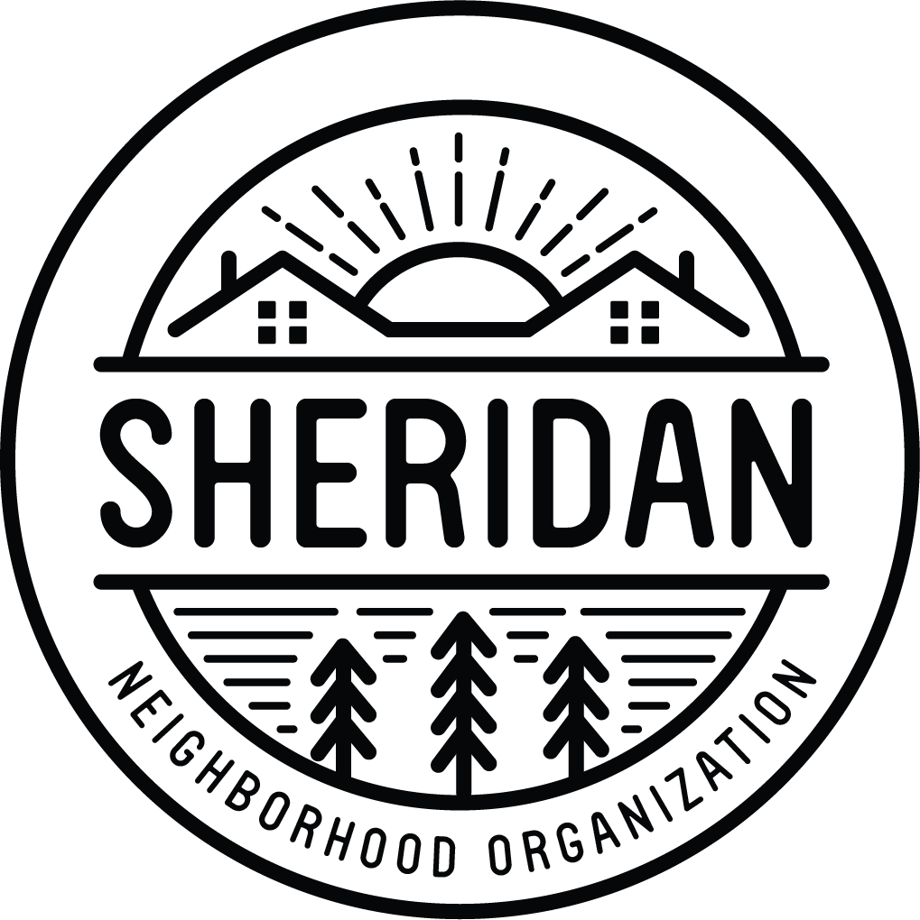
Sheridan Neighborhood Organization
www.sheridanneighborhood.org
1304 University Ave NE
Minneapolis, MN 55413
sno@sheridanneighborhood.org

Thank you for your interest in serving on the Board of Directors for Sheridan Neighborhood Organization (SNO)! Our mission is to strengthen and celebrate the community by facilitating connections between the residents, businesses, and institutions of Sheridan through relationship building and collaboration. SNO is dedicated to preserving the neighborhood’s strengths, identifying and helping to address the community’s changing needs, and bringing positive improvements to all.
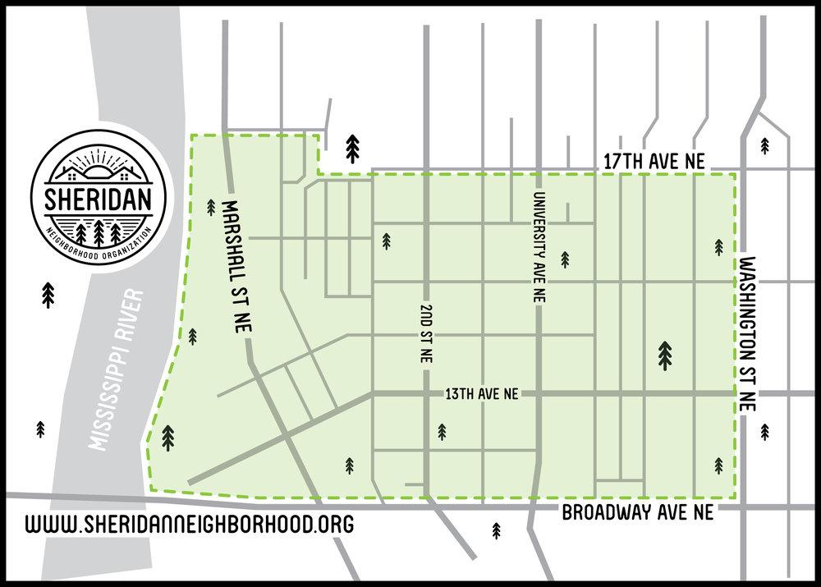

Sheridan’s boundaries extend East and West from the Mississippi Riverfront to Washington St NE, and North and South from 17th Ave NE to Broadway St NE.

We are looking for members to serve on the Board of Directors who are passionate about investing in and serving our diverse community in Sheridan.

Requirements and duties of a Director:

- Two-year term and one-year term options
- You must live, own property, or represent a business or institution in the Sheridan neighborhood to serve on the board.
- Attend monthly board and community meetings on the 4th Monday of every month from 7 - 9PM
- Be available via email for online voting a few times per month
- Total required time commitment is about 5 hours per month, but you are welcome to be more involved by serving on a committee and volunteering at our community events

SNO Board of Directors Application

Name ___________________________________

Email ___________________________________

Address _________________________________

Phone Number ____________________________

Your address and contact information will not be shared publicly.

I am a:
- Sheridan Resident (Renter or Homeowner)
- Sheridan Business Owner or non-residential Property Owner
- Representative of a Sheridan Institution (Schools, Churches, etc)

Briefly answer the following questions:

- What is your connection to the Sheridan Neighborhood?

- Why would you like to serve on SNO’s Board of Directors?

- What is your vision for SNO moving forward? What experiences, skills, or perspectives will you bring to the table to help make that vision possible?

The duties and requirements of a Director are outlined on the cover page. By signing this, you agree to have your name be placed on the board election ballot on Monday, April 26th, 2021. Please indicate your readiness, with your signature, to these duties:

Signature ____________________________________ Date________________

