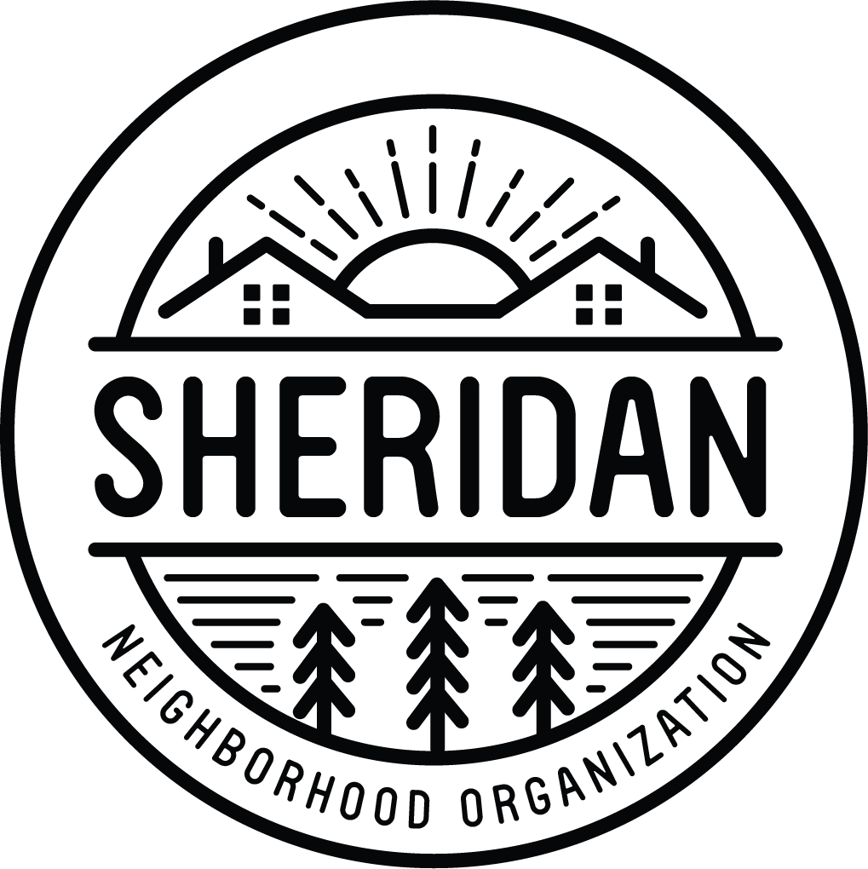
Sheridan Neighborhood Organization
www.sheridanneighborhood.org
1304 University Ave NE
Minneapolis, MN 55413
sno@sheridanneighborhood.org

Waad ku mahadsantahay xiisaha aad u qabto u shaqeynta Golaha Agaasimayaasha ee Ururka Xaafadda Sheridan (SNO)! Hadafkayagu waa inaan xoojino una dabaaldegno bulshada anagoo fududeynayna xiriirka ka dhexeeya dadka deggan, ganacsatada, iyo xarumaha Sheridan iyada oo loo sii marayo xiriirka iyo iskaashiga. SNO waxay u heellan tahay dhowrista awoodda xaafadaha, aqoonsashada iyo gacan ka geysashada iyo wax ka qabashada baahiyaha is beddalaya ee bulshada, iyo u keenista horumarin wanaagsan dhammaan.
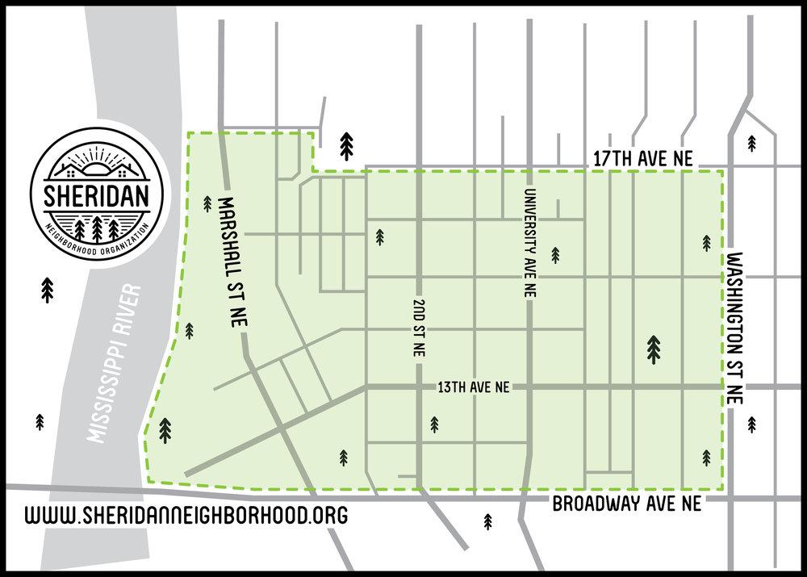

Xuduudaha Sheridan waxay gaarsiisan yihiin Bariga iyo Galbeedka laga soo bilaabo Mississippi Riverfront ilaa Washington St NE, iyo Waqooyiga iyo Koonfurta laga bilaabo 17aad Ave NE ilaa Broadway St NE.

Waxaan raadineynaa xubno ka shaqeeya Golaha Agaasimayaasha oo xiiseynaya maalgashiga iyo u adeegida bulshooyinka kaladuwan ee Sheridan.

Shuruudaha iyo waajibaadka Agaasimaha:

- Xulasho laba sano iyo hal sano ah
- Waa inaad ku nooshahay, leedahay hanti, ama aad metelaysaa meherad ama xarun xaafadeedka Sheridan si aad ugu adeegtid guddiga.
- Ka qaybgal guddiga billaha iyo shirarka bulshada maalinta Isniinta 4-aad ee bil kasta laga bilaabo 7 - 9PM
- Ka heli kartaa emayl ahaan si aad ugu codeyso khadka internetka dhowr jeer bishii
- Wadarta waqtiga loo baahan yahay bil kasta waa 5 saacadood, laakiin waxaa lagugu soo dhaweynayaa inaad ka qaybqaadato adigoo ka soo shaqeynaya guddi iyo iskaa wax u qabso munaasabadaha bulshadaada

Codsiga Guddiga Agaasimayaasha (Board of Directors Application)

Magaca ____________________________________

Email _____________________________________

Cinwaanka _________________________________

Teleefan Nambarka __________________________

Cinwaankaaga dadweynaha lalama wadaagi doono.

Waxaan ahay:
- Ku nool Sheridan Resident (Kiraysta ama Mulkiilaha Guryaha)
- Idan Milkiile Ganacsi Sheridan ama Mulkiile Hanti Aan Deganeyn
- Wakiilka Hay'ada Sheridan (Iskuulada, Kaniisadaha, iwm)

Si kooban uga jawaab su'aalahan soo socda:

- Muxuu yahay xiriirka aad la leedahay Xaafadda Sheridan?

- Maxaad u jeceshahay inaad u adeegto Golaha Agaasimayaasha SNO?

- Muxuu yahay aragtidaada SNO horay u socotaa? Khibrado, xirfado, ama aragtiyo noocee ah ayaad u keeni doontaa miiska si aad uga caawiso suurtogalnimada aragtidaas?

Waajibaadka iyo shuruudaha Agaasimuhu waxay ku qeexan yihiin bogga hore/sare. Saxiixidda tan, waxaad ogolaatay in magacaaga lagu dhigo liiska codbixinta guddiga Isniinta, Abriil 26, 2021. Fadlan ku muuji diyaarsanaantaada, saxiixaaga, waajibaadkaan:

Saxiixa ____________________________________ Taariikhda________________

